Assignment Description
Complete exercises 11-17 on page 391 of your Invitation to Computer Science textbook

Question 11 (4 points)
  - Assume there is a wide area network with N nodes, where N >= 2. What is the smallest number of point-to-point communication links such that every node in the network is able to talk to every other node? (Note: A network in which some nodes are unable to exchange messages with other nodes because there is no path between them is called disconnected.)
Put answer here:
The minimum number of nodes you could have where N >= 2 and each node talks to every node is 3 nodes. As shown below, this allows each node to connect to the other nodes, but if you increase by one node, there becomes an inability to connect one pair of nodes to all other nodes.
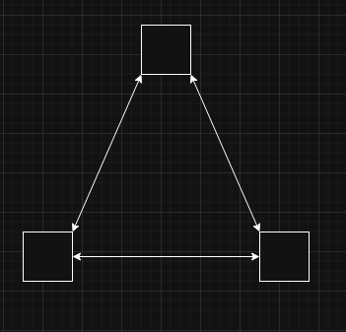

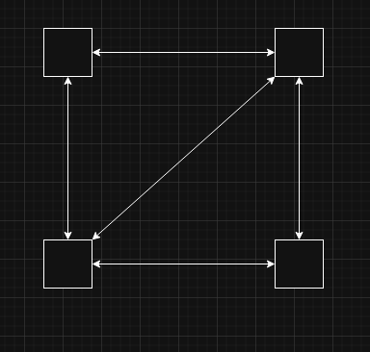
  - If you are worried about having a disconnected network, what type of interconnection structure should you use when configuring your network?
Put answer here:
You would want an interconnection structure similar to the image below from page 351, Chapter 7. This shows a hybrid network setup that utilizes a router to send out a signal to the various connected devices depending on the type of connection that is required. This allows for devices to connect using a wired or wireless connection as needed. This also allows a company or individual to keep local resources segregated from publicly accessible resources, which is an important security concern when discussing networking setup and configuration as well.

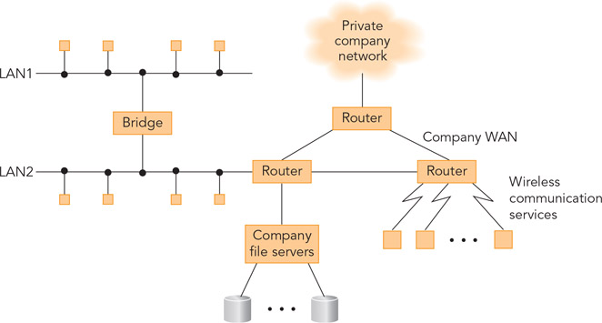

Question 12 (2 points)
In Exercise 11, you determined the minimum number of links needed to ensure that every one of the N nodes in a network can communicate with every other node. However, most networks have far more than this minimum. What are the advantages of having these “extra” links in the network?
Put answer here:
The advantage of having more links in the network is that there are more paths for the signal to take as it tries to navigate the network. This allows for both more efficient pathing to a particular device, but also allows for multiple paths to the device in the event of failure.

Question 13 (2 points)
What happens to the store-and-forward protocol of Figure 7.9 if a packet M is repeatedly sent from node A to node B but never correctly arrives at B? (Perhaps the link from A to B is broken.) What modifications can we make to this protocol to handle this situation?

Put answer here:
As more and more packets are sent to node B, node A continues to store the failed packets in memory, resulting in degraded network performance and potentially dropped packets for other, unrelated traffic. The modifications that could be made to this protocol are partially addressed by the ARQ protocol, where the receiving node is designed to send an ACK signal back to the sending node to confirm the packet was not lost or corrupted. If the packet was not received in a certain amount of time, the sending node would try a certain number of times before trying to send the packet through an alternate route.

Question 14 (2 points)
The ARQ algorithm described in Section 7.3.2 is quite inefficient because the sending node must stop sending until it receives an explicit ACK from the receiving node. Can you design a modification to the ARQ protocol that makes it more efficient by not requiring the sender to stop and wait each time it sends a message? Describe your revised protocol in detail.

Put answer here:
Inverting the protocol so that it always sends the packets a certain number of times unless the sending node receives an explicit ACK from the receiving node for each packet would be one method to reduce the inefficiency caused by this wait time. Additionally, only resending the failed/error packets, rather than sending all packets, is another method (which is called Selective Repeat ARQ) to improve the efficiency of the protocol.

Question 15 (2 points)
How could we broadcast a message using an ARQ algorithm? That is, how do we send the same message to 100 different nodes on a WAN?
Put answer here:
Sending the message to each node, one at a time (called unicasting) would be the ideal method. Starting at a source node, the source node would wait for an ACK, then proceed to the next node, repeating this process until all nodes have been sent and acknowledged.

Question 16 (6 points)
Given the following diagram, where the numbers represent the time delays across a link:
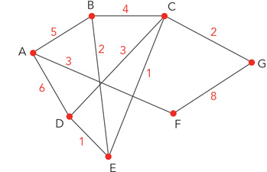
- How many simple paths (those that do not repeat a node) are there from node A to G?

Put answer here:
The possible paths from A -> G are:
A -> F -> G = time delays of 3 + 8 = 11
A -> D -> C -> G = time delays of 6+ 3 + 2 = 11
A -> D -> E -> C -> G = time delays of 6 + 1 + 1 + 2 = 10
A -> D -> E -> B -> C -> G = time delays of 6 + 1 + 2 + 4 + 2 = 15
A -> B -> C -> G = time delays of 5 + 4 + 2 = 11
A -> B -> E -> C -> G = time delays of 5 + 2 + 1 + 2 = 10
- What is the shortest path from node A to node G? What is the overall delay?

Put answer here:
The most efficient paths are either A -> D -> E -> C -> G or A -> B -> E -> C -> G with a delay of 10

- If node E fails, does that change the shortest path? If so, what is the new shortest path?

Put answer here:
Yes, the new shortest path becomes A -> F -> G, since this is tied for the amount of time delay, but has the fewest nodes involved.

Question 17 (2 points)

Here is a simple heuristic (approximation algorithm) for routing a message from node A to node B in a reasonable amount of time. The algorithm assumes that every node in the network has at least two outgoing links.
Assume A has n outgoing links, n >= 2 , with delays to the nodes on the other end of a₁, a₂, …, a_{n}. Select the link with the shortest delay and send the message on that line. If the message arrives at node B, you are done. Otherwise, repeat this process until the message does arrive at its intended destination, but do not send the message directly back to the node from where it just came. That is, if the message was sent from A to C, then C should not return the message to A. In this case, choose the second-lowest delay value for the outgoing line.
Will this heuristic always deliver the message from node A to node B? If not, explain why.
Put answer here: No, the heuristic will not always deliver the message from node A to node B. The reason is that each node can have n >=2 outgoing links with delays to other nodes, but each node may not have the same number of links. If each node had the same number of, the below example could not exist. Although this heuristic may be warranted for situations where you only wanted specific traffic going to node B and no other traffic.
